www.weebly.com
Creating your site:
- Click on “Get Started” and create your account
- Choose the FREE plan
- Most teachers will probably use the “Site” option as your focus
- Choose a theme. (This can always be changed)
- Create your URL. Choose the first option, “Use a subdomain of Weebly.com”
Designing the site:
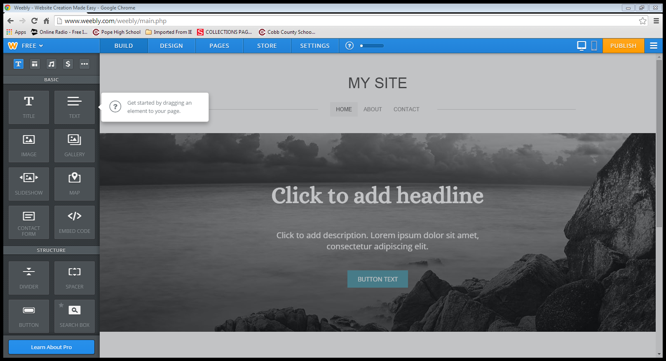

Create a Page:
- Click on the page tab on the menu bar and you will see this screen
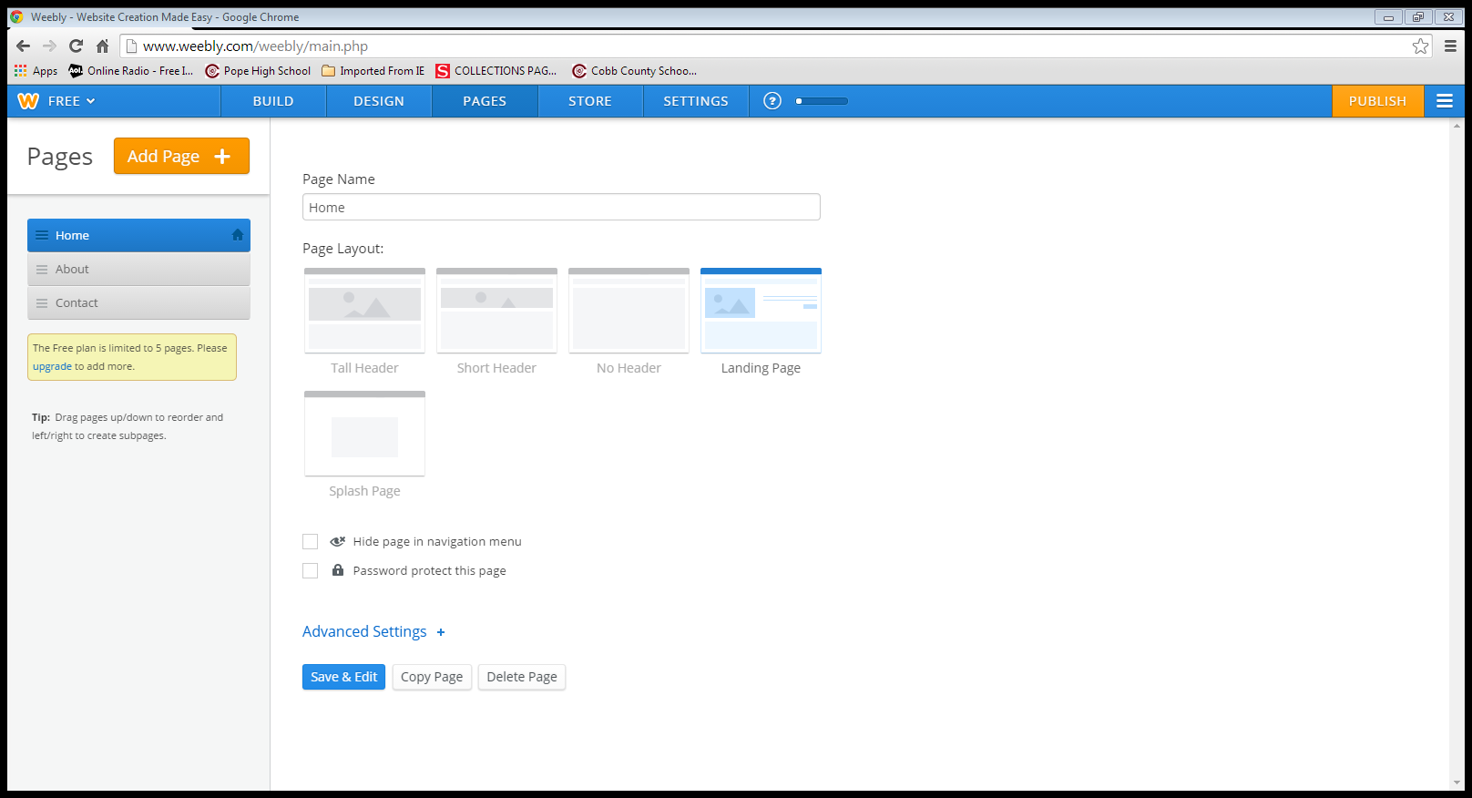
- Type in the page name
- Choose page layout
- Click Save and Edit
- From this point on drag and drop any design element you want. (Be aware that most close to the bottom are for the paid version)
- You have a limit of 5 pages, however you can add as much as you need to each page.
Submitting Documents:
- Under the Basic options choose, Assignment Form and drag to desired spot on your page.
- Be sure to enter the email you would like the assignments to go to.
Contacting the teacher:
- Under the Basic option, choose contact form.
- Be sure to enter the email you would like the message to go to.

Creating a link:
- Using the text option, drag and write in text of choice.
- Highlight that text and choose the chain icon.
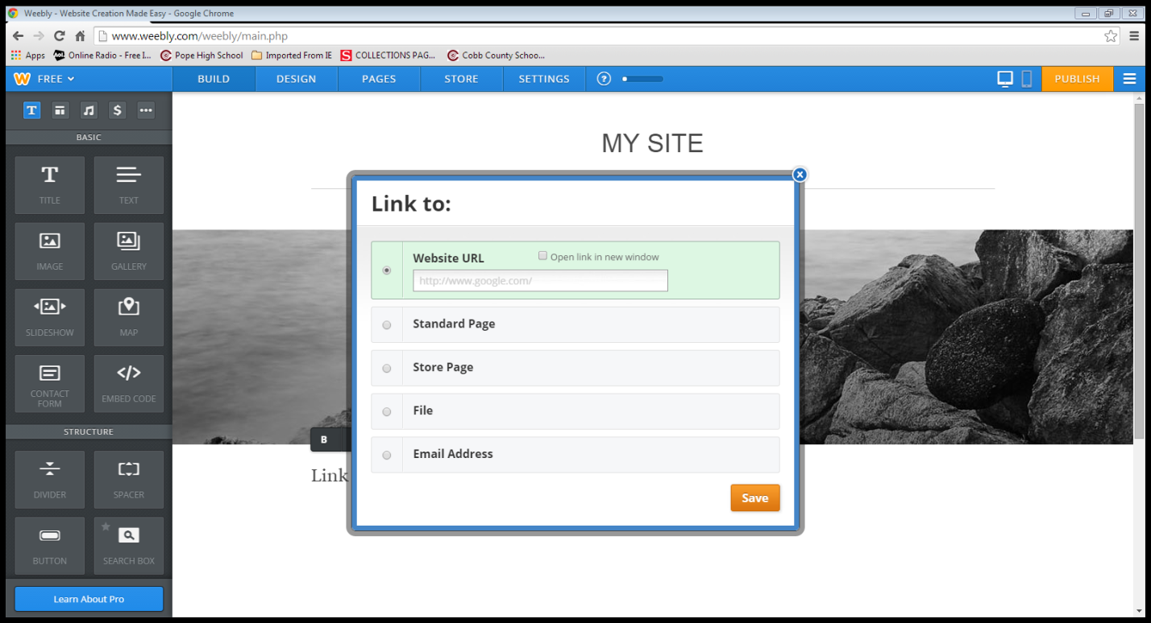
- From here you can either link to a website, or even a file that you will upload.
Publishing your site:
- When you are ready for the world to see your site, click on the orange Publish button at the top right hand corner.
Ways to use in your classroom;
- A teacher website/blog
- Student projects (Something different than power points)
- A forum for student projects that are posted to be viewed on their own time
- Student blog (collaboration)

